Wireframe Document

Heart Disease Diagnostic Analysis

Revision Number: 1.0 Last Date of Revision**:**

**Murala Divyasree**

Homepage

As per the problem statement: Main Dashboard

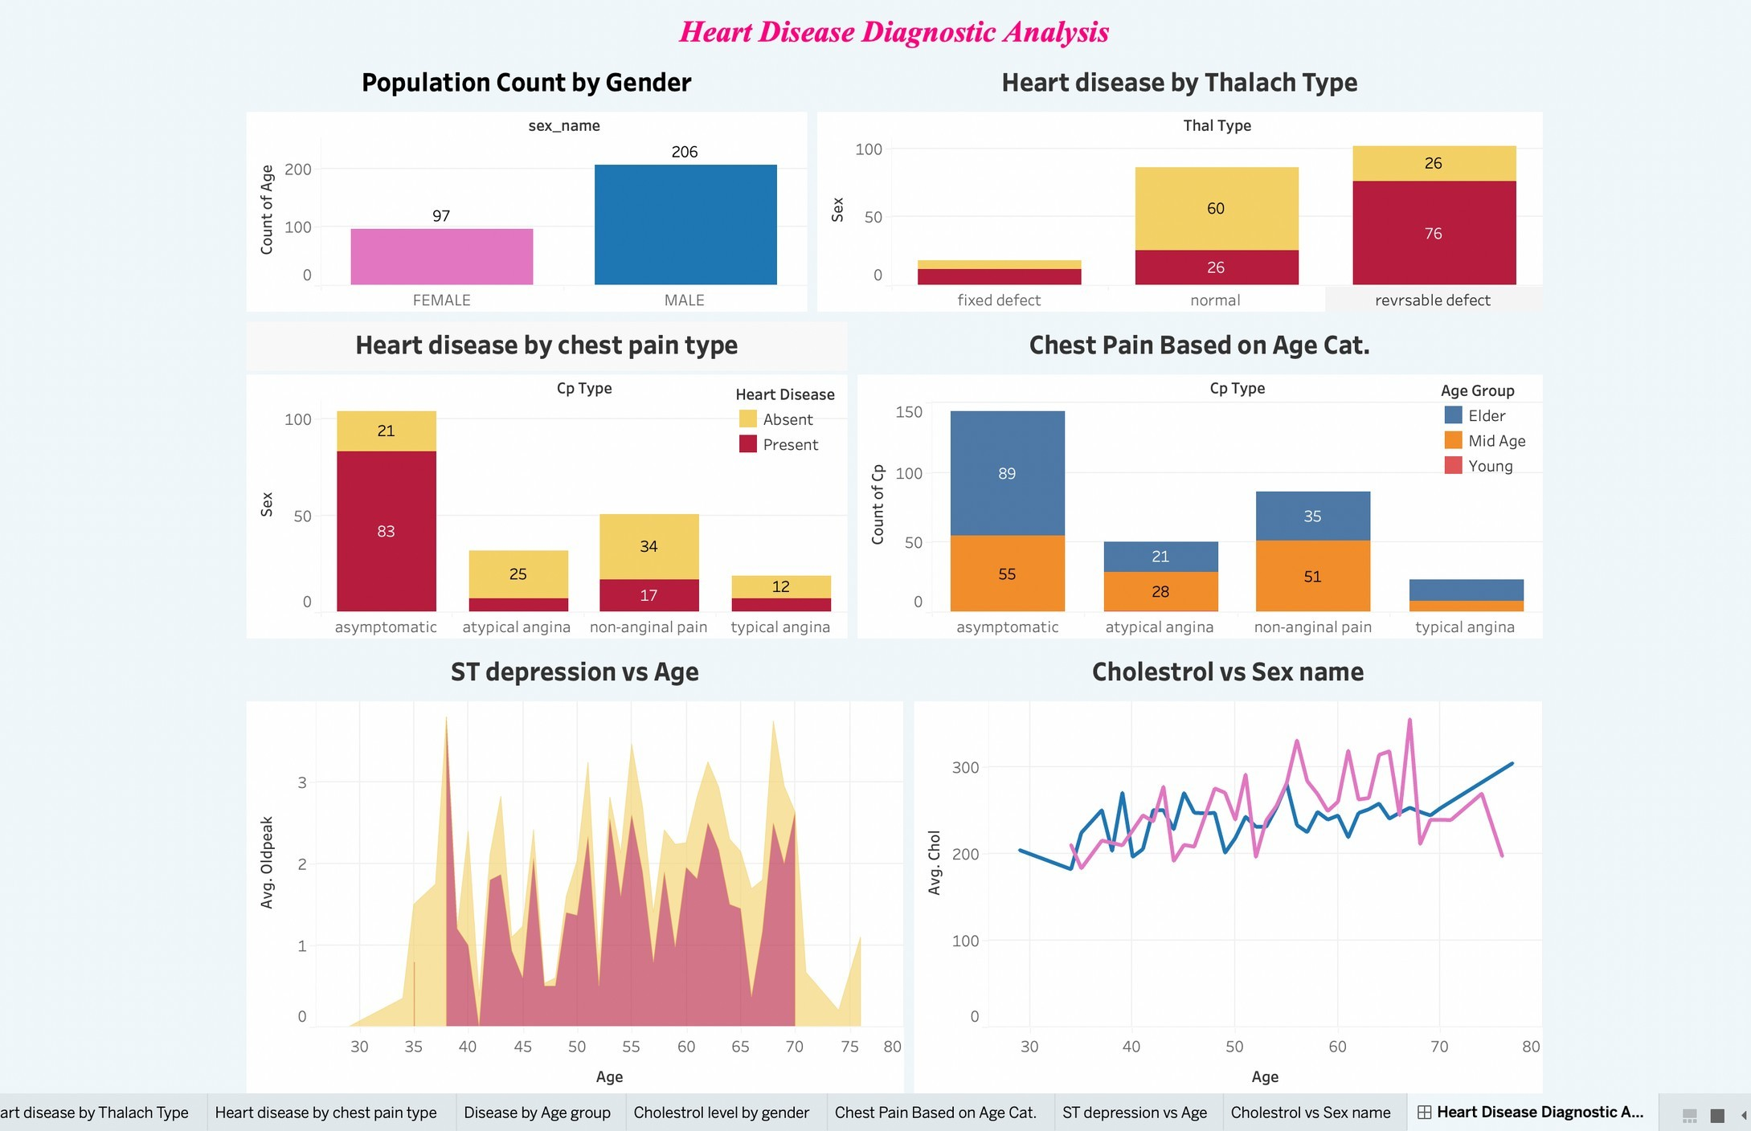

Population count by Gender

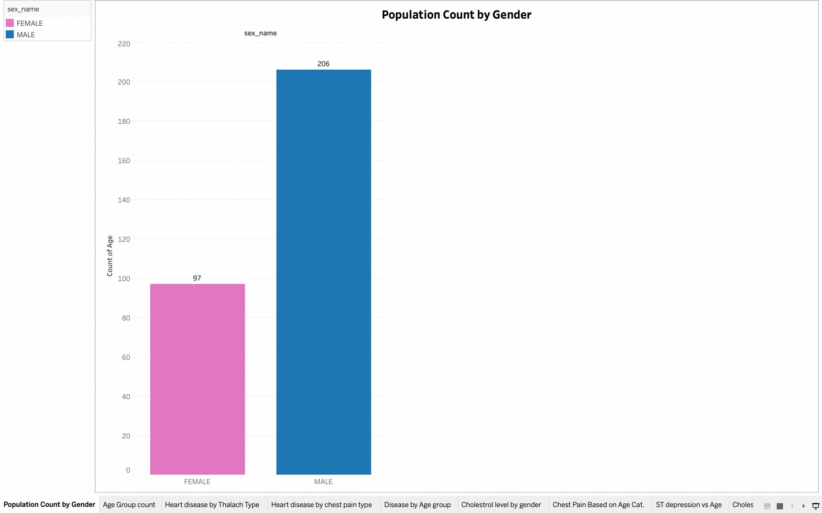

HEART_DISEASE BY CHEST PAIN

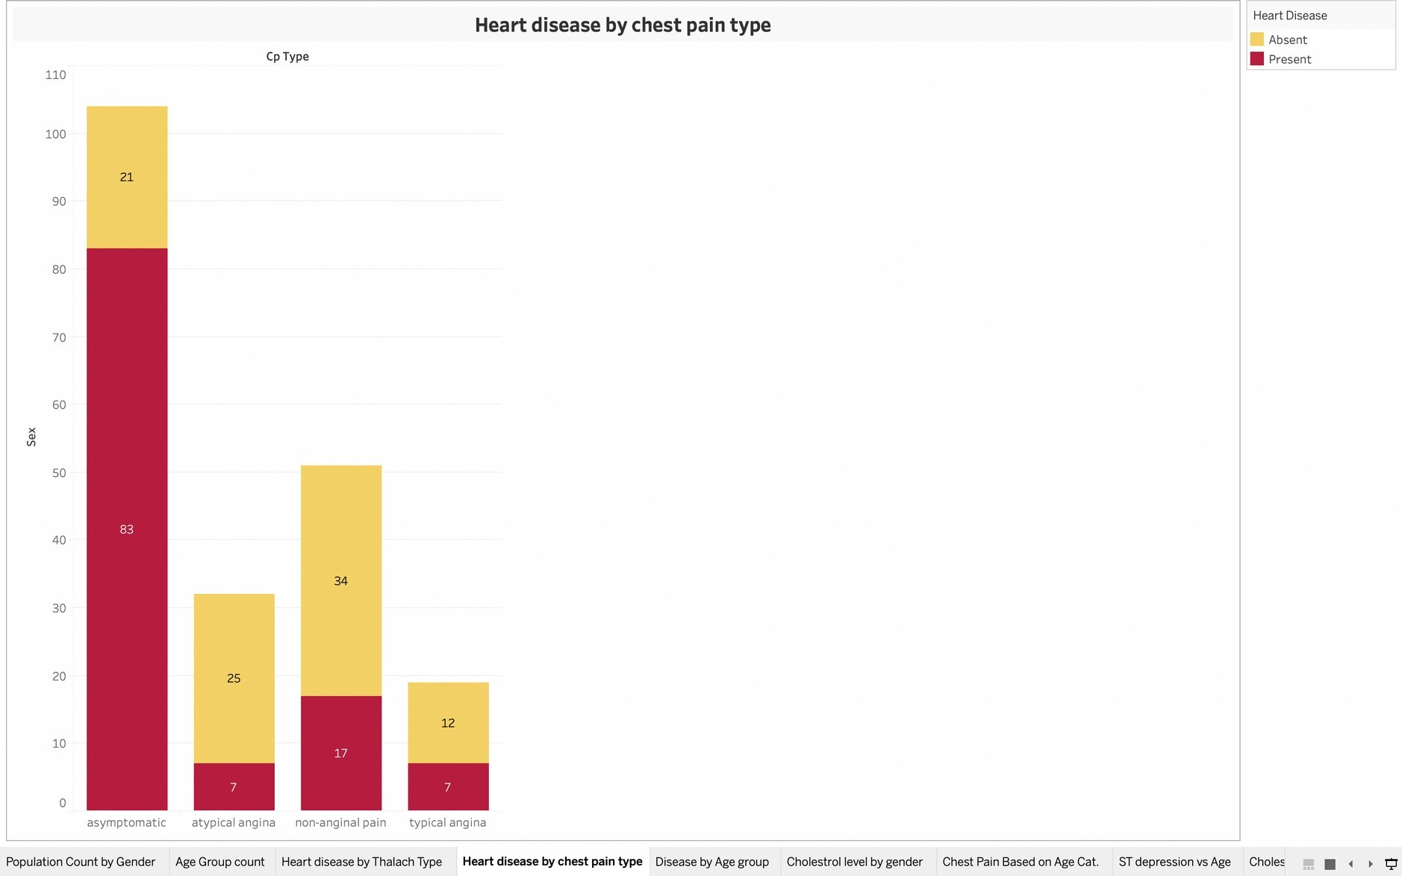

ST Depression vs Age

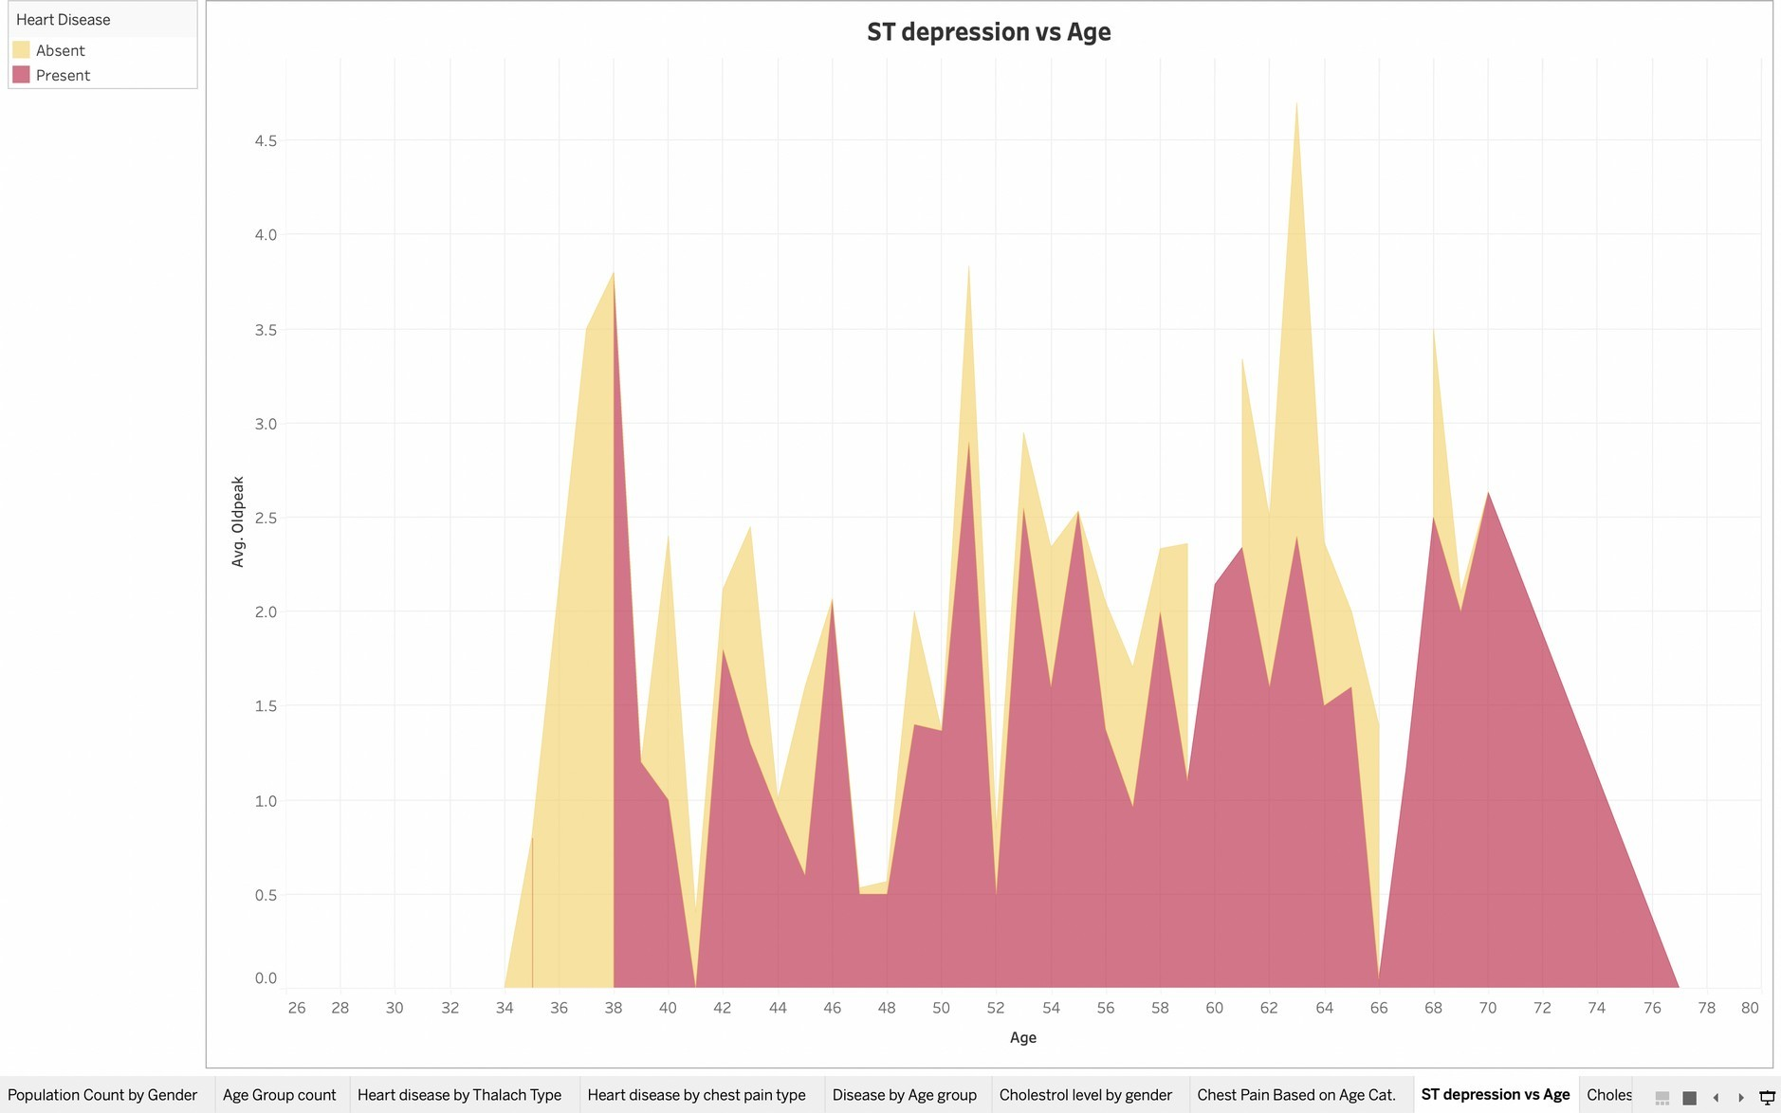

Relation between Companies Sales and Market Cap